User Manual

PAPL DMS SOP

**Table of Contents**

Contents

**1.Purpose** 3

**2.Login** 3

**3.Home Page** 3

**4.Create SOP’s** 4

**5.Document Review** 7

**6.Document Approval** 8

**7.Cancel** 9

**8.Document Index List View** 10

**9.Edit Document** 11

**10. Attached URL for Create SOP’s** 12

11. **Copying existing file path** 12

# **1.Purpose**

User Manual – PAPL DMS will be used by the End users of PAPL to perform the SOP Document Approval.

* Create SOP’s
* Edit SOP’S
* Review
* Approval

# **2.Login**

[Common - Home (sharepoint.com)](https://mrbutlers.sharepoint.com/sites/Common)

Login with your organization Mail Id & Password

# **3.Home Page**

[Common - Home (sharepoint.com)](https://mrbutlers.sharepoint.com/sites/Common)

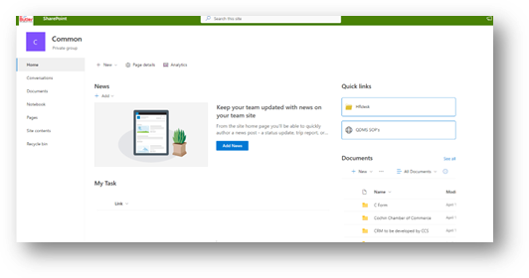

Click on Quick link. This will navigate too the

QDMS-SOP page

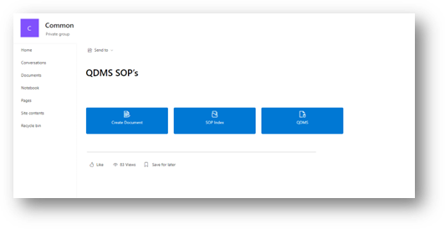

# **4.Create SOP’s**

To create a new SOP, click on the 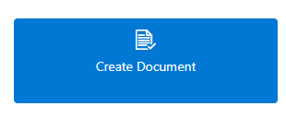Quick link.

Current user can enter the required details and upload the document and submit for review process. 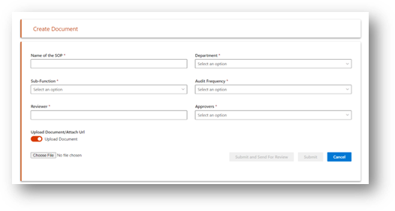

After entering required details User will get two options to submit the form as shown below



Clicking Submit and send for review button user will get popup window to enter the due date and comments if required as shown below.

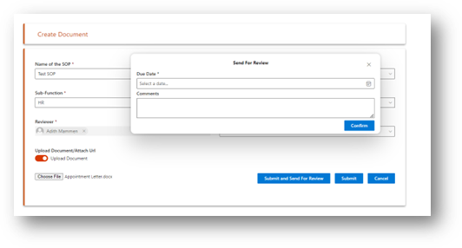

Enter the due date and comments and click on the confirm button.

The reviewer will get a mail notification with a link to review in his outlook mailbox.

|  |  |  |  |
| --- | --- | --- | --- |
| Field | Control | Mandatory | Description |
| Name of the SOP | Text Field | Yes | SOP Name |
| Department | Drop-down | Yes | Date from department list |
| Sub Function | Drop-down | Yes | Data from Subfunction list |
| Audit Frequency | Drop-down | Yes | Data from audit frequency list |
| Reviewer | People Picker | Yes | Populating on selecting department from department list |
| Approver | Drop-down | Yes | Populating on selecting department from department list |
| Submit and send for review | Button | No | Submit and send for review process |
| Submit | Button |  | Submit and save in Index List |
| Cancel | Button |  | Will redirect to home page |

User can Submit the form and later send for Review and Approval by Edit the document from the document Index List View. Refer **8. Document Index List View & 9 Edit** Document session for more details.

# **5.Document Review**

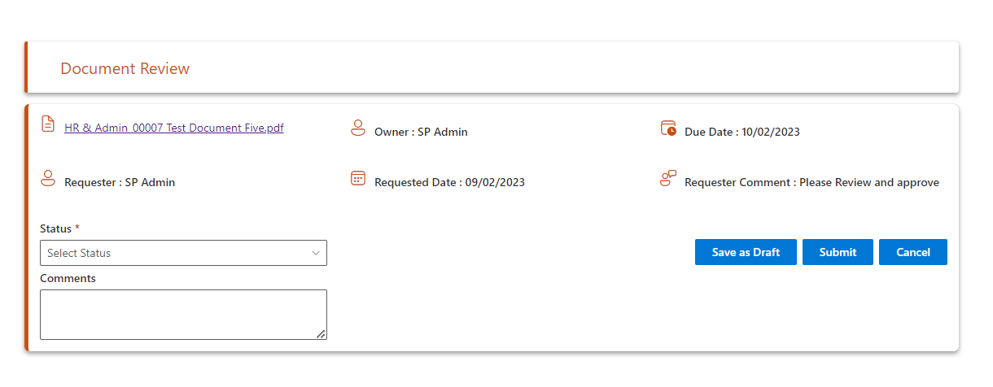

|  |  |  |  |
| --- | --- | --- | --- |
| Field | Control | Mandatory | Description |
| Status | Drop-down | Yes | Review Status |
| Comments | Text – Field | No | Comments |

On Submit click the process will proceed to next level, approval process.

# **6.Document Approval**

The approver will get a notification in his mailbox with a link to the approve page. 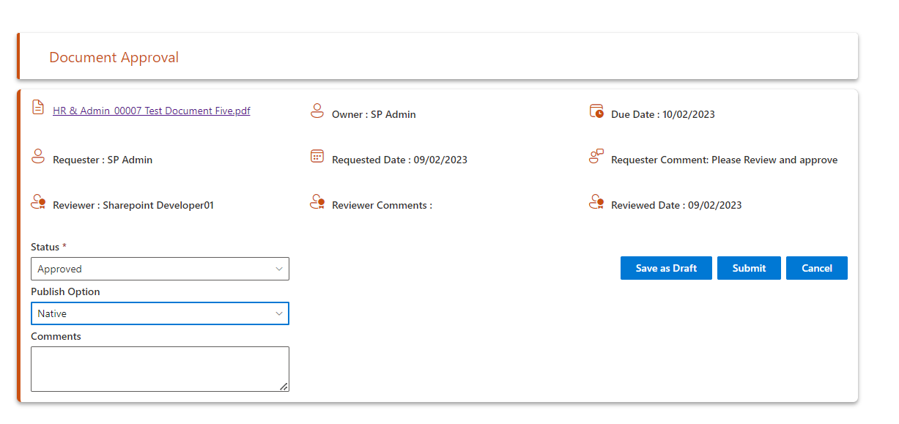  
  
On status drop down selection, select publish option and click on submit.

|  |  |  |  |
| --- | --- | --- | --- |
| Field | Control | Mandatory | Description |
| Status | Drop-down | Yes | Review Status |
| Comments | Text – Field | No | Comments |
| Publish Option | Drop-down | Yes | To be published in |

If the approver Approved the document, then the document gets published in the published document library and copied to the common location for all users to view the document.

The user will be able to see the newly published document from the home page.

Quick link

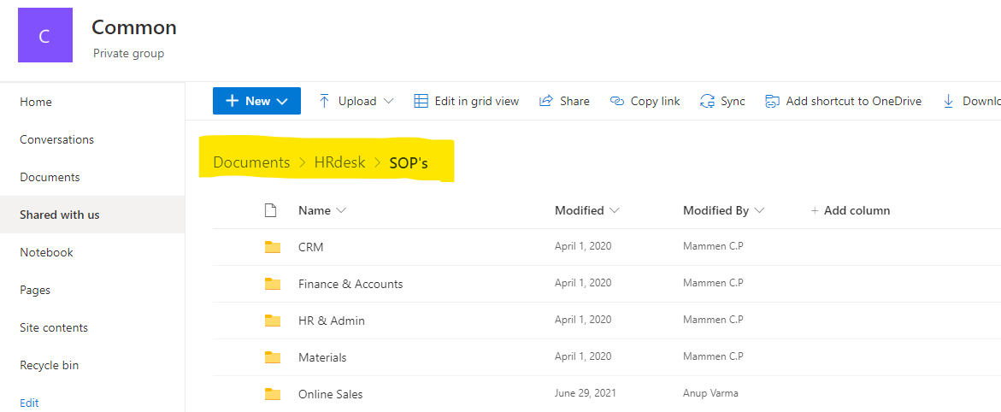

If the Approver Rejected the document by selecting Return with comments or rejected, then document creator will get a mail notification with the reason for rejection.

# **7.Cancel**

On clicking cancel button a dialogue box will be displayed as below and on selecting yes, user will be redirected to home page.

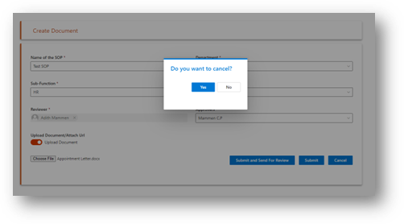

# **8.Document Index List View**

User can navigate to this view from the home page by clicking on the  quick link.

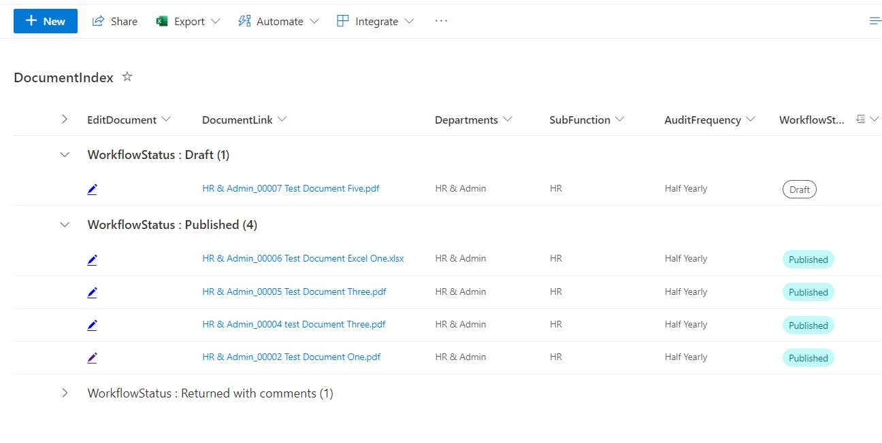

# **9.Edit Document**

If a user wants to edit any document, thenclick on the edit icon from document index view.

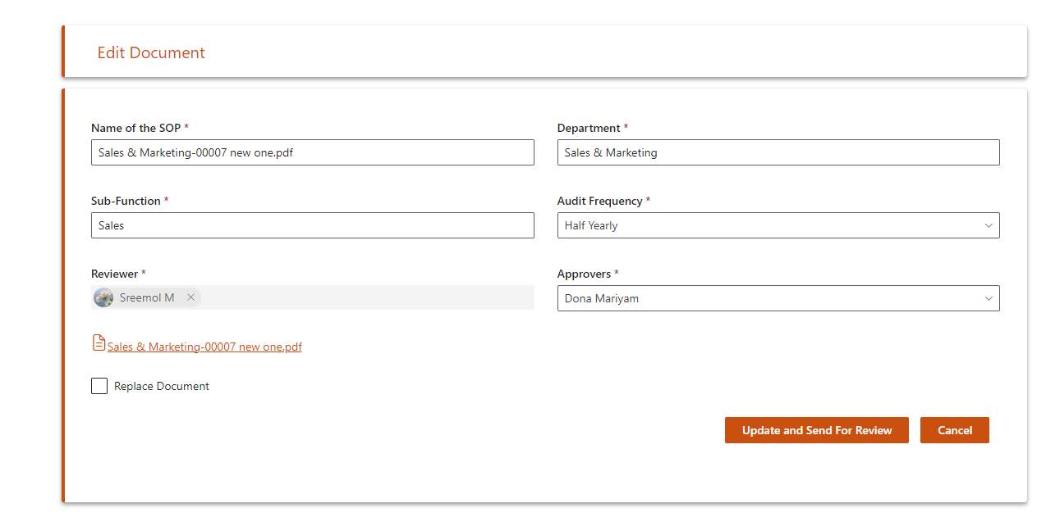

To replace the document Check “Replace Document.”

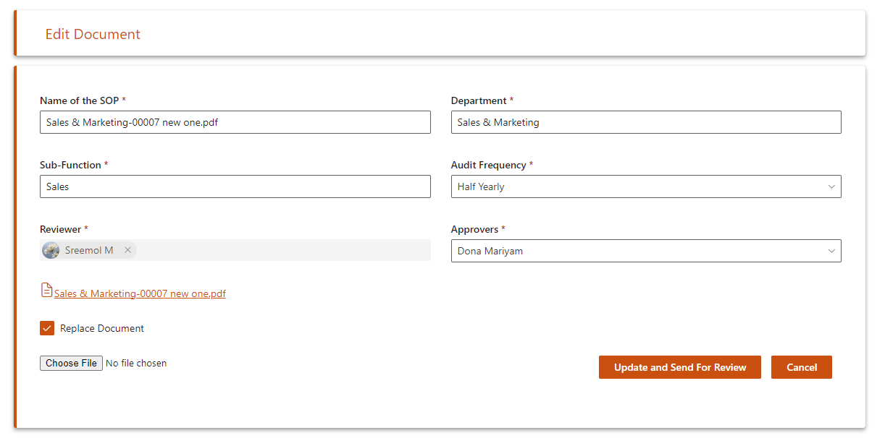

Upload the same document type and then click update or send for review button.

# **10. Attached URL for Create SOP’s**

Users can copy paste the file location URL for creating the SOP. By default, the user has the option to attach the file.

Click the toggle to attach the file path URL.

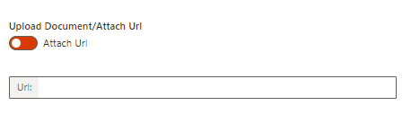

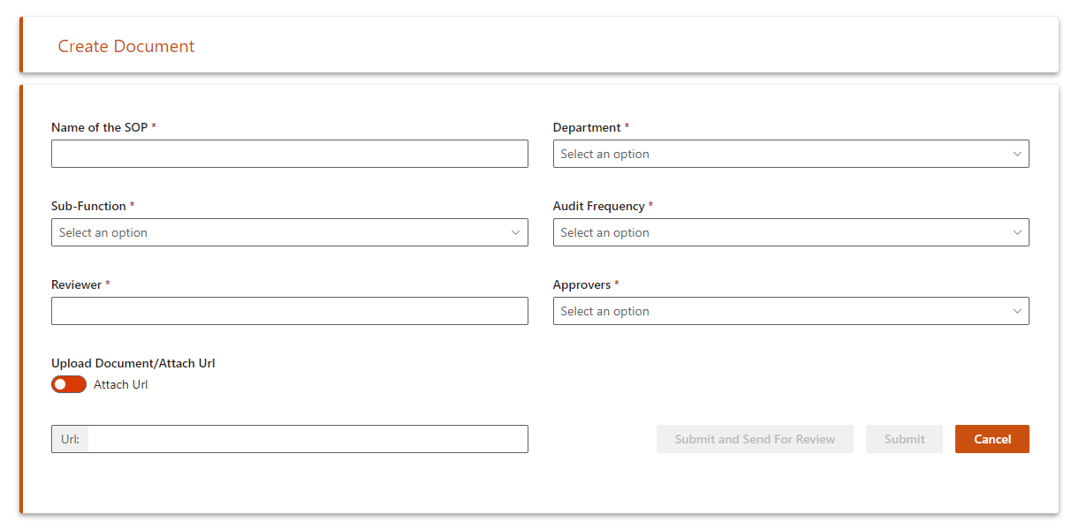

# 11. **Copying existing file path**

1. Click on file item.

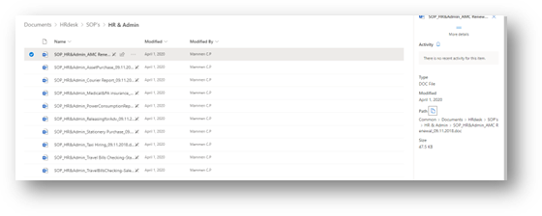

b) Click on the open details pane.

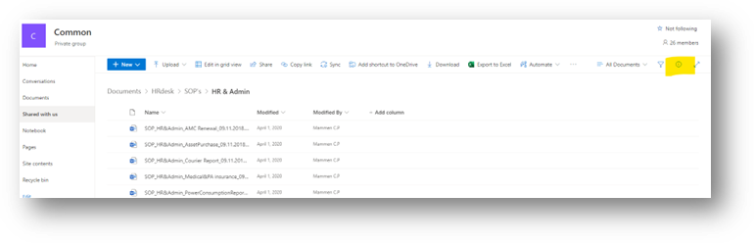c) Click on path.

